4

Ocean Graham

Abstract

A portfolio presenting a collection of exercises in relation to the XYZ Tech Solutions specifications, exploring different aspects of various operating systems.

401IT – Operating Sysytems

Coursework 2 Portfolio of Operating Systems



Table of Contents

Table of Figures 1

Introduction 3

Installation of different operating systems 3

Linux Ubuntu 3

Windows 11 7

Windows Server 2022 11

usage of different operating systems 16

Command Line Interface Usage 16

User Account Management 18

Linux Ubuntu 18

Windows 11 22

Windows Server 2022 25

Linux and Windows Scripting 28

Linux 28

Windows 11 29

Server 2022 31

managing vulnerabilities 32

Operating System Security risks and vulnerabilities 32

Technologies and management Strategies for risk mitigation 32

COnclusion 32

References 32

# Table of Figures

Figure 1 - Ubuntu ISO installation 3

Figure 2 - Ubuntu Virtual Machine creation 4

Figure 3 - Ubuntu Set up User and Password 4

Figure 4 - Ubuntu Define Resource allocation 4

Figure 5 – Ubuntu Assign Disk space and finish creation 5

Figure 6 - Ubuntu Startup screen 5

Figure 7 - Ubuntu preparing 5

Figure 8 - Ubuntu copying files 6

Figure 9 - Ubuntu login screen 6

Figure 10 - Windows 11 ISO Download 7

Figure 11 - Windows 11 Virtual Machine creation 7

Figure 12 - Windows 11 Set up User and Password 8

Figure 13 – Windows 11 Define Resource allocation 8

Figure 14 - Windows 11 Assign Disk space and finish creation 8

Figure 15 – Windows 11 Fail to boot error 9

Figure 16 - Windows 11 Boot manager 9

Figure 17 - Windows 11 Boot Manager Menu 9

Figure 18 - Windows 11 Optical Disk Selection 10

Figure 19 – Windows 11 Installation 10

Figure 20 – Windows 11 Successful Installation 11

Figure 21 - Server 2022 ISO download 11

Figure 22 - Server 2022 Virtual Machine creation 12

Figure 23 - Server 2022 Set up User and Password 12

Figure 24 – Server 2022 Define Resource allocation 12

Figure 25 – Server 2022 Assign Disk space and finish creation 13

Figure 26 - Server 2022 installation 13

Figure 27 – Server 2022 Successful Installation 13

Figure 28 - Server 2022 GUI Setup 14

Figure 29 - Server 2022 GUI Setup Desktop Experience selection 14

Figure 30 - Server 2022 Installation 2 14

Figure 31 - Server 2022 GUI Post download setup screen 15

Figure 32 - Server 2022 Home screen 15

Figure 33 - Ubuntu navigation and file manipulation 16

Figure 34 - Windows 11 Script navigation 1 17

Figure 35 - Windows 11 Script navigation and file manipulation 1 17

Figure 36 - Windows 11 Script navigation and file manipulation 2 17

Figure 37 - Windows 11 Script navigation and file manipulation 3 18

Figure 38- Ubuntu GUI User creation 19

Figure 39- Ubuntu GUI User creation password selection 19

Figure 40 - Ubuntu GUI User created 20

Figure 41 - Ubuntu CLI User creation - Intern 20

Figure 42 - Ubuntu CLI User creation - Admin 21

Figure 43- Ubuntu give Admin user Sudo/Admin privileges 21

Figure 44 - Ubuntu created Users 21

Figure 45 - Windows 11 GUI Account creation setting 22

Figure 46 - Windows 11 GUI User creation – Intern 22

Figure 47 - Windows 11 GUI User creation - Admin 23

Figure 48 - Windows 11 GUI User creation - Account types 23

Figure 49 - Windows 11 GUI Users created 24

Figure 50 - Windows 11 CLI User creation 24

Figure 51 - Windows 11 All Users created 25

Figure 52 - Server 2022 GUI User created - Server Manager 25

Figure 53 - Server 2022 CLI User created – Admin 26

Figure 54 - Server 2022 Group creation 26

Figure 55 - Server 2022 Groups created 27

Figure 56 - Server 2022 Group Privilege assignment - Server Manager 27

Figure 57 - Server 2022 Group Privilege assignment - Admin 27

Figure 58 – Ubuntu Script test file 28

Figure 59 - Ubuntu Script code 28

Figure 60 - Ubuntu Script output 29

Figure 61 - Ubuntu Script test file backed up 29

Figure 62 - Windows 11 Script 30

Figure 63 - Windows 11 Script output 31

Figure 64 - Server 2022 Script 31

401IT – Operating Systems

# Introduction

This coursework will demonstrate a high degree of understanding of operating systems via a collection of exercises conducted for XYZ Tech solutions. This coursework is designed as a portfolio which is divided into 3 sections each displaying understanding of different aspects within different operating systems (Ubuntu Linux, Windows 11 and Windows Server 2022).

# Installation of different operating systems

VirtualBox, was utilised to simulate a real-world IT infrastructure as expected of XYZ Tech Solutions. VirtualBox was used to create 3 virtual Operation Systems, these being Linux Ubuntu, Windows 11 and Windows Server 2022. This section will display the installation process of these 3 Operating systems via the virtual machines.

## Linux Ubuntu

Figure 1 - Ubuntu ISO installation

Figure 2 - Ubuntu Virtual Machine creation

Figure 3 - Ubuntu Set up User and Password

Figure 4 - Ubuntu Define Resource allocation

Figure 5 – Ubuntu Assign Disk space and finish creation

Figure 6 - Ubuntu Startup screen

Figure 7 - Ubuntu preparing

Figure 8 - Ubuntu copying files

Ubuntu restarts after successful installation and results in this login screen. This concludes the installation of Linux.

Figure 9 - Ubuntu login screen

## Windows 11

Figure 10 - Windows 11 ISO Download

Figure 11 - Windows 11 Virtual Machine creation

Figure 12 - Windows 11 Set up User and Password

Figure 13 – Windows 11 Define Resource allocation

Figure 14 - Windows 11 Assign Disk space and finish creation

Figure 15 – Windows 11 Fail to boot error

Going into the boot manager and selecting the CD-ROM option can get into the system. However, on shutdown of the system, this boot error repeats.

Figure 16 - Windows 11 Boot manager

Figure 17 - Windows 11 Boot Manager Menu

Figure 18 - Windows 11 Optical Disk Selection

Attempt to attach Windows 11 ISO to optical drive as well as remove unattended files, to resolve issue.

An alternative version of windows was installed with different settings (double the Hard Disk Memory of the original) which resolved the originals boot problems.

**Figure 19 – Windows 11 Installation**

Figure 20 – Windows 11 Successful Installation

## Windows Server 2022

Figure 21 - Server 2022 ISO download

Figure 22 - Server 2022 Virtual Machine creation

Figure 23 - Server 2022 Set up User and Password

Figure 24 – Server 2022 Define Resource allocation

Figure 25 – Server 2022 Assign Disk space and finish creation

Figure 26 - Server 2022 installation

Figure 27 – Server 2022 Successful Installation

A second version of Server 2022 was installed as the original lacked a GUI.

Figure 28 - Server 2022 GUI Setup

Figure 29 - Server 2022 GUI Setup Desktop Experience selection

Figure 30 - Server 2022 Installation 2

Figure 31 - Server 2022 GUI Post download setup screen

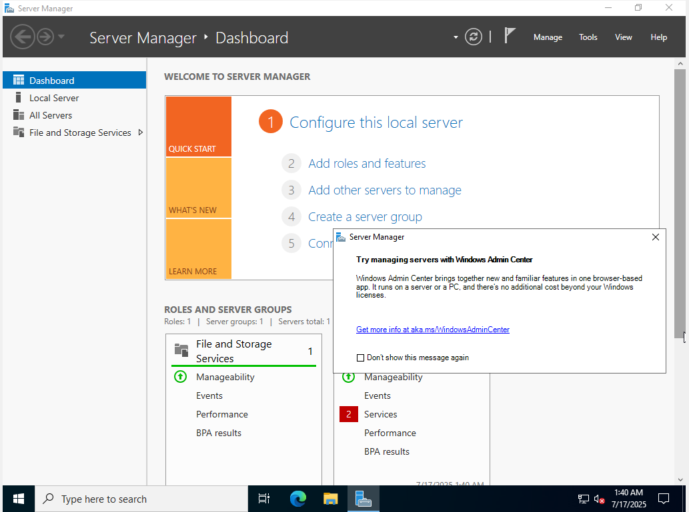

Figure 32 - Server 2022 Home screen

Successful Installation of Windows Server 2022

# usage of different operating systems

## Command Line Interface Usage

The command line is a valuable tool for performing different tasks on an operating system, being able to navigate, manipulate files and folders as well as automate processes (Scripting, which we will discuss later)

Figure 33 - Ubuntu navigation and file manipulation

Figure 34 - Windows 11 Script navigation 1

Figure 35 - Windows 11 Script navigation and file manipulation 1

Figure 36 - Windows 11 Script navigation and file manipulation 2

Figure 37 - Windows 11 Script navigation and file manipulation 3

## User Account Management

User account management is the effective management of users and their accounts, this controls access to resources such as devices, files and applications. (Soni, 2021) This allows admins to allow or restrict access based on an organisational role the user performs. User management is essential in ensuring security and safety within an organisation, meaning users have access to only items they have clearance for based on their hierarchy. (Mohite, 2024)

Multiple different accounts of different authority across the different systems have been created, these being based on roles and where they would work within the XYZ Tech Solutions Organisation.

### Linux Ubuntu

GUI Creation - Developer:

Figure 38- Ubuntu GUI User creation

Figure 39- Ubuntu GUI User creation password selection

Figure 40 - Ubuntu GUI User created

CLI Creation – Admin, Intern:

Figure 41 - Ubuntu CLI User creation - Intern

Figure 42 - Ubuntu CLI User creation - Admin

(The Admin group is the predecessor to Sudo (Prior to 12.04 LTS) this being replaced by Sudo in later versions)

Figure 43- Ubuntu give Admin user Sudo/Admin privileges

Figure 44 - Ubuntu created Users

### Windows 11

GUI Creation – Admin, Intern:

Figure 45 - Windows 11 GUI Account creation setting

Figure 46 - Windows 11 GUI User creation – Intern

Figure 47 - Windows 11 GUI User creation - Admin

Give Admin higher clearance with the Administrator Account type.

Figure 48 - Windows 11 GUI User creation - Account types

Figure 49 - Windows 11 GUI Users created

CLI Creation – Developer, Human resources:

Figure 50 - Windows 11 CLI User creation

Figure 51 - Windows 11 All Users created

### Windows Server 2022

GUI Creation – Server Manager:

Figure 52 - Server 2022 GUI User created - Server Manager

CLI Creation – Admin:

Figure 53 - Server 2022 CLI User created – Admin

Group Creation

“Groups are a collection of users who share the same permissions or privileges” (Solanki, 2024). Groups make it easier for an organisation to assign privileges on a larger scale. Group creation was done via Windows Server 2022.

Figure 54 - Server 2022 Group creation

Figure 55 - Server 2022 Groups created

Figure 56 - Server 2022 Group Privilege assignment - Server Manager

Figure 57 - Server 2022 Group Privilege assignment - Admin

## Linux and Windows Scripting

Scripting is a useful tool in reducing error and the time it takes to perform a usually repetitive task. A script is a file ((.sh) for Linux) or ((.ps1) for Windows) that contains a string of commands for a shell to execute (GeeksforGeeks, 2017).

Some scripts have been developed across the different OS to present some potential uses and the advantages of using scripts for the XYZ Tech Solutions company.

### Linux

On Linux a File Backup script was developed.

Figure 58 – Ubuntu Script test file

Figure 53 is the test file for the script to copy.

Figure 59 - Ubuntu Script code

Each line of this code has a different purpose.

* Line 1 is the string that makes it perform as a script rather than a word document with random characters.
* Line 2 and the final line both are ‘echo’ commands which just prints the quoted text out.
* Line 3 defines the location that is getting backed up
* Line 4 defines the location to send the backup
* Line 5 and 6 both define the naming convention to the backup (date dd/mm/yyyy and system name)
* Line 7 assigns Line 5 and 6 to the document
* Line 8 actually creates the backup file in a tgz folder.

Figure 60 - Ubuntu Script output

The tgz folder contains the backup to be opened, Figure 55 displaying the a regular folder and a zipped file, this tgz file is easier to keep and share across organisation.

Figure 61 - Ubuntu Script test file backed up

### Windows 11

On Windows 11, the script creates presents the cpu information, as well as current cpu and memory usage.

Figure 62 - Windows 11 Script

This script is broken into 3 sections.

* Section 1 holds the CPU information block, this works by assigning a command that gets the CPU info put into the variable ‘$cpuInfo’, this is then put through a for loop which separates the info out for ease of user understanding.
* Section 2 Gets the cpu usage.
* Section 3 Gets the memory usage.

Section 2 and 3 work in similar ways, subtracting free cpu/memory, then dividing used by total memory.

Figure 63 - Windows 11 Script output

### Server 2022

On Windows Server 2022, a script was developed that would check the last password reset of each user and force a password reset if it passed 60 days. This script however does not function due to this study for the XYZ Tech Solutions company not being a complete network, therefore not joined into a domain which some commands required.

Figure 64 - Server 2022 Script

A for loop is used for the script to re-enact for each user on the system.

As said priorly, this script does not work due to the lack of active server and domain. The ‘ADUser’ command not functioning as a result of this lack of domain controller, identified by the ‘False’ response after the line with an error on the script activation.

# managing vulnerabilities

## Operating System Security risks and vulnerabilities

## Technologies and management Strategies for risk mitigation

# COnclusion

# References